
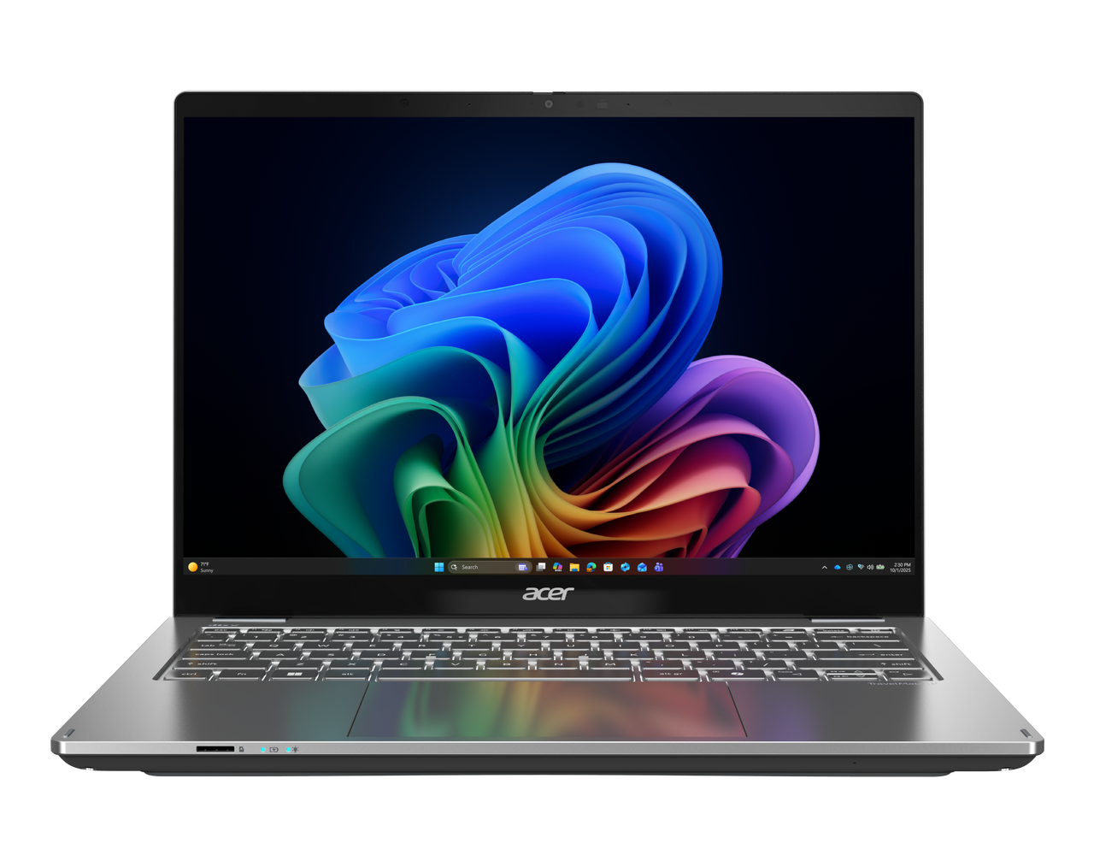

TravelMate P4 Spin 14 AI

SPECIFICATIONS |  |  |  | Acer TravelMate P4 Spin 14 AI |  |  |  | P414RN-56 | P414RN-56-TCO  P414RN-76 | P414RN-76-TCO
 | 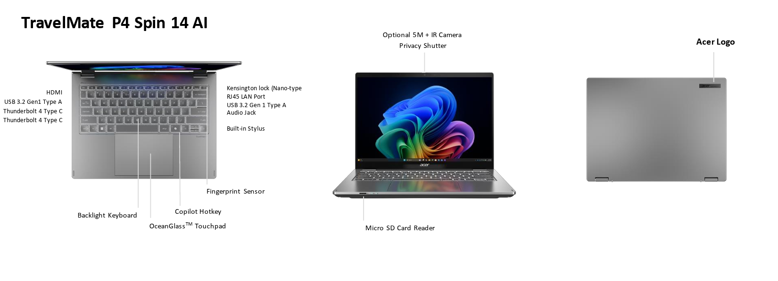
 | Operating System |  | Windows 11 Pro (Acer recommends Windows 11 Pro for business.)  Windows 11 Home
 | CPU and Chipset |  | P414RN-56  Intel® Core™ Ultra 5 processor 322  Intel® Core™ Ultra 5 processor 325 |  |  | Intel® Core™ Ultra 5 processor 335  Intel® Core™ Ultra 5 processor 355  Intel® Core™ Ultra 5 processor 365 |  |  | P414RN-76  Intel® Core™ Ultra 7 processor 356H
 | Memory |  | Dual-channel DDR5 SDRAM | Two SO-DIMM modules | Up to 64 GB system memory | Up to 5600 MT/s memory frequency
 | Display |  | 14.0" display with IPS (In-Plane Switching) technology | WQXGA+ 2880 x 1800 | Acer ComfyView™ | Integrated multi-touch  16:10 aspect ratio | 100% sRGB color gamut | Wide viewing angle | Mercury free, Environment friendly| AES 2.0 stylus support |  |  |  | 14.0" display with IPS (In-Plane Switching) technology | WUXGA 1920 x 1200 | Acer ComfyView™ | LED-backlit LCD | Integrated multi-touch  16:10 aspect ratio | Super-slim design | Mercury free, Environment friendly | AES 2.0 stylus support
 | Graphics |  | Intel® Graphics eligible  Graphics Special Technology: AVC, VP9, AV1 HW Accelerated Video Decode | AVC, AV1 HW Accelerated Video Encode | Microsoft DirectX 12 | OpenGL 4.6 | OpenCL 3.0
 | Audio |  | DTS® X:Ultra Audio, featuring optimized Bass, Loudness, Speaker Protection with up to 3 custom content modes via smart amplifier  Smart Auto switch to Voice enhanced Mode via VOIP  High SNR DAC with 2.1 Vrms out capability and can driver high impedance headphone (up to 600 ohm)  Compatible with Cortana with Voice |  |  |  | Acer Purified.Voice technology with AI noise reduction in 3 mics array built-in microphones to support Advanced Privacy Mode. Features include far-field pickup, dynamic noise reduction through neural network, adaptive beam forming, and pre-defined personal and conference call modes.  Acer TrueHarmony Technology for lower distortion, wider frequency range, headphone-like audio and powerful sound
 | Storage |  | Solid state drive: 1 x SSD slot | 256 GB / 512 GB / 1 TB | PCIe Gen 4 | 16 Gb/s | NVMe
 | Webcam |  | Video Conferencing  UFC with double T-type USB 5 MP camera | 2880 x 1800 resolution | 1800p 5 MP video at 30 fps with temporal noise reduction | Dual microphones (33 mm + 33 mm) | Blue glass lens | Windows compatible only  UFC with USB 5 MP and IR camera | 2880 x 1800 resolution | 1800p 5 MP video at 30 fps with temporal noise reduction | Dual microphones | Blue glass lens | Windows compatible only
 | Wireless and Networking |  | WLAN: Intel® Wi-Fi 7 wireless LAN | 802.11 a/b/g/n/ac/ax/be | 2x2 MIMO technology | 2.4 GHz | 5 GHz | 6 GHz | Intel vPro® Enterprise | Intel® Connectivity Performance Suite (ICPS) |  |  |  | WPAN: Bluetooth® 5.4 or above | Bluetooth LE Audio (LC3  LAN: Gigabit Ethernet, Wake-on-LAN ready)
 | Security |  | Power keycap fingerprint reader | On-chip matching design  Acer ProShield Plus security manager includes: Data protection: File and folder encryption and decryption, Personal Security Drive | Data removal: File shredding | Security alert: Invalid access alert, Security report  Discrete Trusted Platform Module (TPM) solution | BIOS passwords: User, Supervisor, HDD (OPAL) | Kensington lock (Nano-type) | Camera shutter
 | Dimensions and Weight |  | Dimensions  312.8 (W) x 231.6 (D) x 16.9/17.1 (H) mm (12.31 x 9.12 x 0.67/0.67 inches) with Metal A Cover |  |  |  | Weight  1.365 kg (3.01 lbs.) with 4-cell battery pack, WQXGA display
 | Power Adapter and Battery |  | Power Adapter  Power adapter  100 W PD PCR 50% | TCO 10.0 AC adapter  Output power | 5 V / 3 A | 9 V / 3 A | 12 V / 3 A | 15 V / 3 A | 20 V / 5 A  Dimensions | 108.0 (W) x 56.0 (D) x 26.5 (H) mm  Weight | 296 g ± 5% with 150 cm DC cable  Black color with Acer logo | Brick-type AC pins | Paper sleeve packaging |  | Battery  P414RN-56 | P414RN-56-TCO  71 Wh 4-cell Li-ion battery | Supports fast charging technology  For models with WQXGA+ panel + SSD | Up to 13 hours based on MobileMark® 2030 test results | Up to 20.5 hours based on video playback test results | Up to 17.5 hours based on web browsing test results  For models with WUXGA panel + SSD | Up to 12 hours based on MobileMark® 2030 test results | Up to 23 hours based on video playback test results | Up to 17 hours based on web browsing test results  Notes | Config: Intel® Core™ Ultra 7 processor 355 | 512 GB SSD | 8 GB + 8 GB memory | WQXGA+ display | Config: Intel® Core™ Ultra 5 processor 322 | 256 GB SSD | 8 GB + 8 GB memory | WUXGA display  P414RN-76 | P414RN-76-TCO  71 Wh 4-cell Li-ion battery | Supports fast charging technology  For models with WQXGA+ panel + SSD | Up to 13.5 hours based on MobileMark® 2030 test results | Up to 20.5 hours based on video playback test results | Up to 16 hours based on web browsing test results  Notes | Config: Intel® Core™ Ultra 7 356H processor | 1 TB SSD | 16 GB + 16 GB memory | WQXGA+ display
 | Input and Control |  | Keyboard  80 / 81 / 84 keys | Acer backlit keyboard layout | International language support  Lightweight design | Embedded LED indicators for Caps Lock and microphone mute | 1.6 mm key travel  Control keys  Microsoft Copilot key | TravelMate Sense key |  |  |  | Touchpad  Multi-gesture touchpad | Two-finger scroll | Pinch gesture | Gestures to open Cortana | Action Center | Multitasking | Application commands  Microsoft Precision Touchpad certification | Moisture resistant | Corning® Gorilla® Glass
 | System Compliance |  | P414RN-56 | P414RN-76  ENERGY STAR® compliance | Wi-Fi® | EPEAT® registered |  |  |  | P414RN-56-TCO | P414RN-76-TCO  ENERGY STAR® compliance | Wi-Fi® | EPEAT® registered | TCO Certified
 | Windows Desktop Apps |  | In-House Applications  Acer AI Image Generator | Acer Display Lens | Acer LiveArt | Acer ORD Service | Acer QR Capture | Acer QuickPanel | Acer Video Speed Controller | TravelMate Sense
 | Warranty |  | One-year International Travelers Warranty (ITW)
 | Disclaimers
 | • | Specifications vary depending on model.
 | • | Shared system memory may be allocated to support graphics, depending on system memory size and other factors. Actual system memory available to the operating system will be reduced by any memory used by the graphics solution and resources required by the operating environment.
 | • | Memory speed may vary, depending on the CPU, chipset or memory fitted.
 | • | All brands and product names mentioned herein include trademarks of their respective companies and are used solely to describe or identify the products.
 | • | Not all features indicated are supported on all SKUs
 | • | 1 GB is 1 billion bytes. Actual formatted capacity is less and may vary depending on preloaded materials and operating environment. Acer Recovery Management uses a portion of the stated hard disk capacity as dedicated backup space.
 | • | Minor variations in system dimensions are possible due to the manufacturing process.
 | • | Listed battery life is based on testing using video playback. The test clip loops continuously, without interruption or any additional input, until the battery is drained. Stated battery life is for comparison purposes only. Actual battery life varies by model, configuration, applications, video format, and features used. A battery’s maximum capacity decreases with time and use. Battery life test configuration: Intel® Core™ Ultra 7 processor (Series 3), Intel® Graphics, WQXGA+, SSD only, 32 GB DDR5 memory. Battery life test condition: LCD brightness at 150 nits, connected headphones, WLAN off, Bluetooth off, and Better Battery mode on.
 | • | Listed battery life is based on testing using web browsing. The test loads 50 selected websites using Microsoft Edge every 30 seconds until the battery is drained. Stated battery life is for comparison purposes only. Actual battery life varies by model, configuration, applications, video format, and features used. A battery’s maximum capacity decreases with time and use. Battery life test configuration: Intel® Core™ Ultra 7 processor (Series 3), Intel® Graphics, WQXGA+, SSD only, 32 GB DDR5 memory. Battery life test condition: LCD brightness at 100 nits, speaker volume at 50%, WLAN on, Bluetooth on, and no WWAN direct Internet connection.
 | • | Actual battery life may vary considerably depending on product model, configuration, applications, power management settings, operating conditions, and features used. Performance variation also depends on the components in use, including but not limited to the processor, RAM capacity, storage, display, and resolution.
 | • | Weight may vary depending on product configuration, vendor components, manufacturing variability, and selected options.
 | • | Bundled software may vary depending on hardware configuration, OS and regional availability.
 | • | EPEAT® registration varies by country. See http://www.epeat.net/ for registration status for each country.

Specifications based on TravelMate P414RN-56 Specifications (v1-0-0) (Preview) and TravelMate Spin P414RN-76 Specification

In a continuing effort to improve the quality of our products, information in this document is subject to change without notice. Images shown are only representations of some of the configurations available for this model. Availability may vary depending on region.
As a phenomenon known to thin-film transistors (TFTs), liquid crystal displays (LCDs) commonly exhibit a small number of discoloration dots, as so-called "non-conforming pixels." This phenomenon is a limitation of TFT LCD technology, not a product defect, and as such is not covered by Acer's warranty.
© 2026. All rights reserved.
Microsoft and Windows are registered trademarks of Microsoft Corporation.
3D XPoint, Agilex, Altera, Arc, Arria, Avalon, Axxia, Barefoot Networks, the Barefoot logo, the Footsie logo, Celeron, Cyclone, Docea, DoubleShot, eASIC, easicopy, FlexRAN, Gaudi, Granulate, Hyperflex, Intel, the Intel logo, Intel Adaptix, Intel Agilex, Intel Atom, Intel CoFluent, Intel Core, Intel Evo, Intel Geti, Intel Inside, the Intel Inside logo, Intel Optane, Intel RealSense, Intel SpeedStep, Intel Tiber, Intel Unison, Intel vPro, Iris, Killer, Linutronix, MAX, Movidius, Myriad, Nios, OmniBridge, OpenVINO, the OpenVINO logo, Pentium, Quartus, Simics, SmartByte, SoftSilicon, Sound Mark, StarPro, Stay With It, the Engineering Stay With It logo, Stratix, the Stratix logo, The Journey Inside, Thunderbolt, the Thunderbolt logo, Tofino, Ultrabook, VTune, and Xeon are trademarks of Intel Corporation or its subsidiaries.

About Acer
Founded in 1976, Acer is one of the world's top ICT companies with a presence in more than 160 countries. As Acer evolves with the industry and changing lifestyles, it is focused on enabling a world where hardware, software and services will fuse with one another, creating ecosystems and opening up new possibilities for consumers and businesses alike. Acer's 7,500 employees are dedicated to the research, design, marketing, sale, and support of products and solutions that break barriers between people and technology. Please visit www.acer.com for more information.

